St. Joseph Catholic School
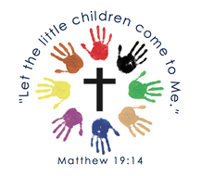

Preschool Handbook

2675 Third Street, Trenton, Michigan 48183
734-676-2565 (School)
734-676-1156 (Preschool Room)

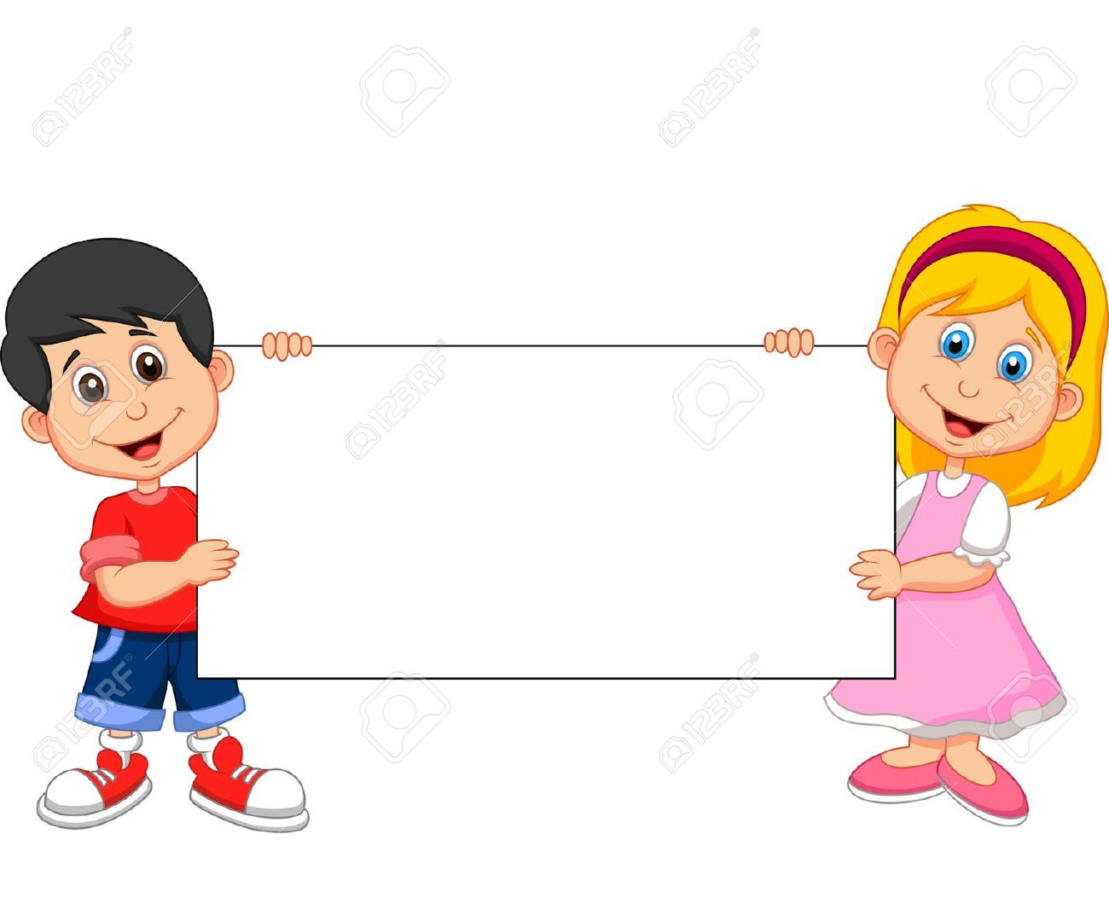

VISION STATEMENT

St. Joseph Catholic Preschool is a faith based,
developmentally appropriate program for
3 and 4 year old children to help them grow
socially, emotionally, physically, and spiritually.

Our goal is to provide sensory development, fine and gross motor activities,
pre-academics, and spiritual awareness, which will prepare your child to become more
independent. He/she will develop social skills in a safe and nurturing environment.

Preschool Objectives:

- To help each child build a good self-concept through continuing success and positive reinforcement.

- To provide a rich background of new experiences, group interaction, and group projects in which each child can develop listening and speaking skills.

- To provide an opportunity for socialization with peers, in which each child can grow in independence and responsibility.

- To provide learning center activities in the following areas to meet the individual needs of each child; gross motor, fine motor, language, and developmental readiness skills.

- To provide opportunities for exploring language and building vocabulary through age appropriate literacy centers.

- To help each child learn new concepts through social interactions and to develop a sense of independence and understanding of others.

- To help each child come to know God’s love as they experience the love of family and friends.

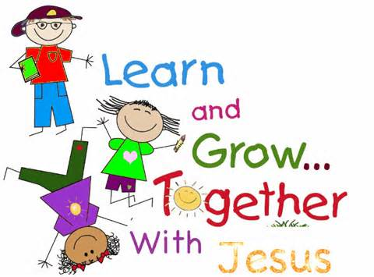

Spiritual Objectives:

The preschool curriculum will emphasize the Biblical statement to “train a child in the way he should go, and when he is old, he will not turn from it.” (Proverbs 22:6) The early education program partners with the home and St. Joseph Church to allow each child to grow and develop using a developmentally appropriate and balanced curriculum. It will follow standards that stress spiritual, intellectual, social, physical, kinesthetic, and emotional development as being equally important.

Spiritual Development/Bible:

Christian, moral and spiritual values are taught in the curriculum and integrated through each day’s lessons in an age-appropriate manner. Bible stories from the Old and New Testament are introduced and presented and taught in ways that are appropriate to the child’s developmental level, Catholic Prayers are introduced and practiced daily. Bible verses will be taught and applied to daily situations. Christian character traits will be modeled and given application in daily interactions. Worship songs and prayer are a natural part of each day.

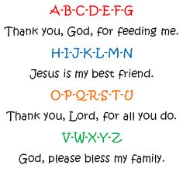

Conferences:
Teacher will request to meet with you twice through the school year. These meetings are important for sharing information on your child’s development. Teachers do regular assessments and will want to share those with you so you can see progress on different skill and social areas throughout the year.

Calendar:
Preschool follows the regular school calendar, although the preschool begins one full week later and ends two weeks before the regular school year. Monthly calendars are sent home in your preschool family packet. Weekly communication is delivered on Fridays and most days it is done via email.

Communication:
Communication with parents is important. The email is filled with information about school, parish, and community happenings. It may include permission slips, newsletters, and more. We include all school information, even if you do not have older children in the school. Teachers will also communicate with you weekly by e-mail or paper. Please check your child’s backpack daily.

Sick Policy:
Please call the school office at (734) 676-2565 and leave a message by 8:30 a.m. if your child will miss school for any reason. Children who are ill should be kept home. (See policy in handbook)

Dress:
Students should dress in appropriate play clothing that is OK to get messy. Dress code is not required for preschool. Students should also have appropriate outdoor clothing, as outdoor play is part of the daily schedule. All students need a change of clothing left at school.

Fundraising:
We ask our preschool families to participate in our school fundraisers. Each preschool family will volunteer 10 hours of their time each calendar year. Hours can be earned by volunteering for lunch duty, classroom preparation and assistance, chaperoning field trips, and running fundraisers. Families unable to donate their time may “buy out” their hours. A fillable form will be available on the website to help track your hours. Hours left unfilled will be charged a rate of $10 an hour.

Class size:
There will always be two adults in our preschool classrooms. For four year old preschool the student to teacher ratio is 12:1 and three year old preschool is 10:1. Teachers are certified in Michigan to teach early childhood.

Supplies:
Teachers will publish a school supply list. Teachers may ask for additional things for special projects throughout the year.
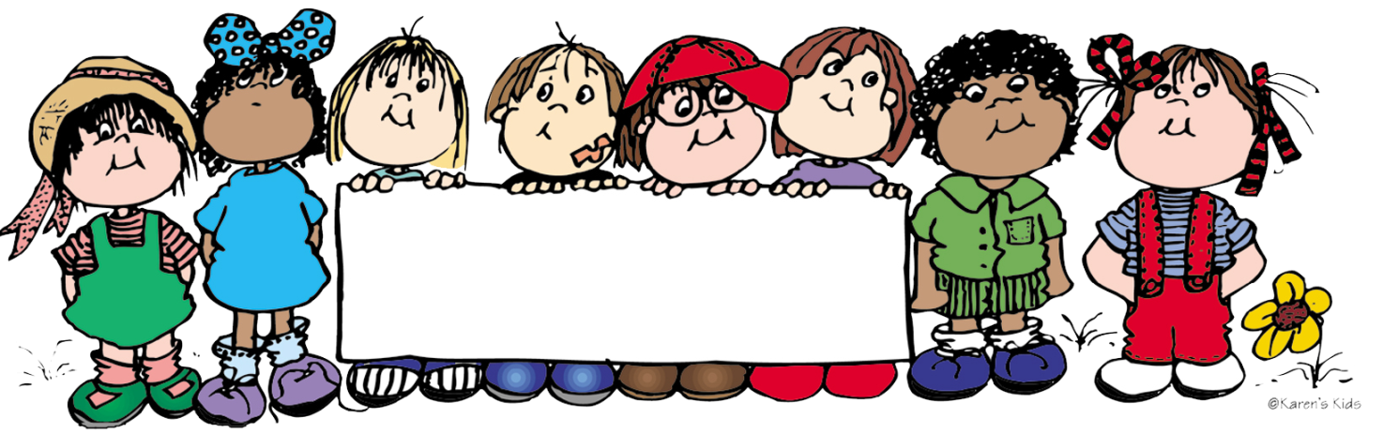

Welcome to St. Joseph Preschool

Mrs. Rinker’s 4 year old Preschool Program
Class is on Monday, Wednesday, and Friday
8:00 a.m. – 11:00 a.m.

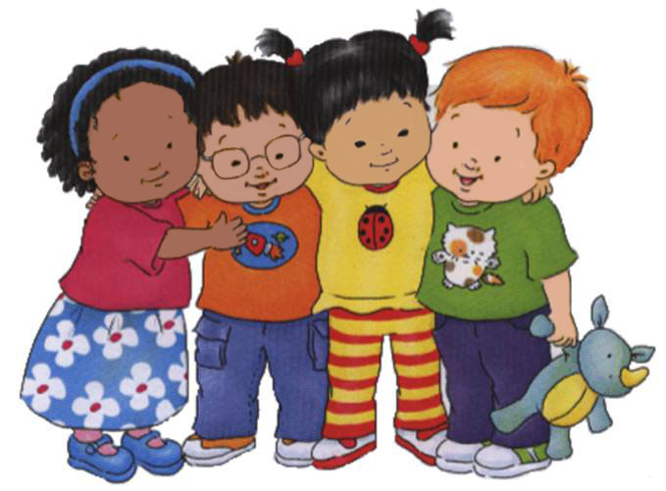
Daily Schedule:

8:00 a.m. Arrival
- Hang up backpack
- Morning Prayers and Pledge of Allegiance
- Sign in on name chart

8:15-8:30 a.m. Circle Time
- Welcome activities
- Calendar, weather, colors, shapes,
Days of the week, & letter of the week
- Finger-plays, songs, story

8:30-8:55 a.m. Centers
- Grosse motor activity/gym

9:00 a.m. Teacher guided activity
- Pre-reading, math, art, and small motor activities

9:45 a.m. Clean up and bathroom break

10:00 a.m. Snack

10:15 a.m. Religion

10:30 a.m. Inside/Outside play

10:50 a.m. Closing Activities

11:00 a.m. Dismissal

*Please provide a healthy snack and drinks must be water or clear juice.
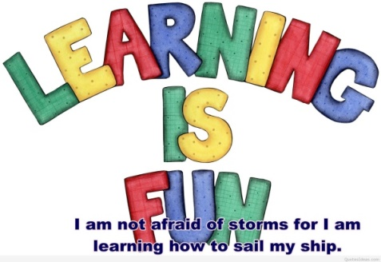

Mrs. Vassar’s 3 year old Preschool Program
Class is on Tuesday & Thursday
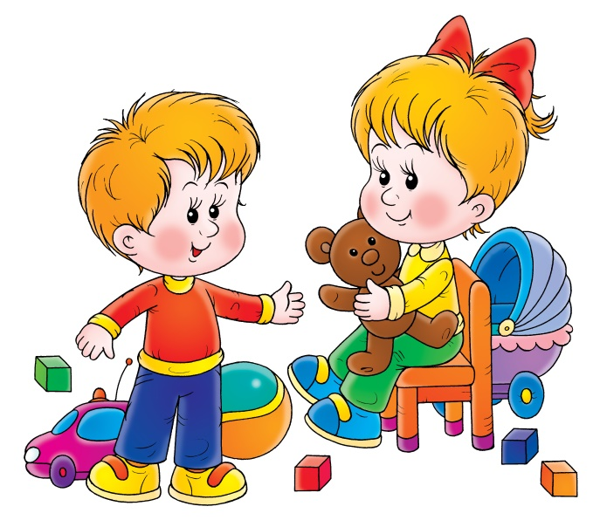
8:00 a.m. – 10:30 a.m.

Daily Schedule:

8:00 a.m. Arrival
- Hang up backpack
- Question of the Day
- Begin table work

8:15 a.m. Circle Time
- Good morning song/prayer/show & tell
- Calendar, weather, ABC’s, 1-2-3’s, shapes & colors
- Finger plays, songs, stories

8:40 a.m. Centers
- Self-directed activities
- Teacher guided activities (small groups)
- Pre-reading, math, art, and small motor activities

9:15 a.m. Religion

9:30 a.m. Bathroom break and snack

10:00 a.m. Grosse Motor

10:15 a.m. Closing Activities

10:30 a.m. Dismissal

Healthy snacks will be provided for the entire class by the student of the day. We are a peanut/nut free classroom. Your child may keep a water bottle in their cubby, if desired. (Clear juices only for snack times please.)

Thursday 8:00-8:20 a.m. Children will select a book from our rolling library. Your child will bring an age appropriate book home each week.
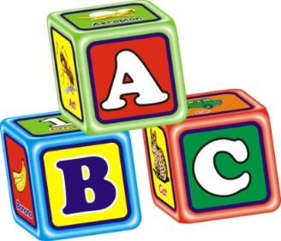

Tuition Rates
2017-2018

St. Joseph Catholic school tuition is paid through the FACTS Management Program.
FACTS is the payment plan provider most widely used by private, faith-based, and public schools nationwide. It helps families meet their financial obligations in a simple, convenient way that is completely confidential and secure. Because it is not a loan program, FACTS does not assess any interest or finance charges, and there is no credit check. Please note there is a $50 late payment fee, if you do not pay by your scheduled monthly day. There is also an automatic $30.00 overdraft fee if you do not have funds in your account on payment day. Please note: You may call ahead of time if there are extenuating circumstances. Please call the parish office at
734-676-9082 extension 25.

To register in FACTS: https://online.factsmgt.com

To enroll your child, you will have to fill out a registration form, provide required documents, register on FACTS and pay a Registration fee of $75.00.
(Registration Fee waived if you have a child that attends St. Joseph Catholic School K-8 and you have already paid a $150.00 registration fee).

Program | Yearly Tuition | 11 payment plan
3 year old preschool  Tuesday & Thursday | $1,034 | $94.00 monthly
4 year old preschool  Mon./Wed./Fri | $1,243 | $113.00 monthly

Enrollment Policy:
St. Joseph Catholic preschool admits children of any race, nationality, or ethnic origin. Students must be 3 or 4 by September 1 to qualify. Students must be completely toilet-trained. Pull ups are not an option.

Required Documents:
- Birth Certificate
- Baptismal Certificate (if applicable)
- Immunization record
- Health Appraisal Form
- All new families must sign a Concussion form

Schoolspeak:
All school correspondence will be sent via email. When filling out your registration form, please provide us with an email address and list your cell phone carrier service.
You will receive an email from Schoolspeak asking you to create a password for your account.
Website: For additional information, and general school policies, please see the Parent/Student handbook, available at www.stjosephschooltrenton.com.

Drop off and pick up policy: The parking lot/play yard cannot be used for 8:00 drop off. Please drive from the north end, down the alley. The teacher will help your child out of the car. All children must be signed in and out each day.
Please pick up your child in a timely manner. There is a charge for late pick up. Teachers cannot begin their clean up and prep until all children have been dismissed for the day.

Potty training: St. Joseph School is not equipped for changing diapers or pull ups. Children must be fully toilet-trained. In case of an accident, we ask all families to provide a change of clothes in a Ziploc bag with your child’s name on it and two pairs of undergarments.

Snack: Children will have a nutritious snack while they are here each day. Also provide a water or clear juice.
Children can bring special treats on their birthdays. Teachers will communicate special needs to accommodate allergies for parties or special dietary needs.

Volunteering/Chaperones: All who wish to help out in the classroom or go on a field trip must fill out a Criminal Background Check and attend a Protecting God’s Children Workshop. After attending the workshop, you should receive a Certificate of completion sent to your home. The office will need a copy of that certificate.
To register for the workshop, you must go online www.virtusonline.org
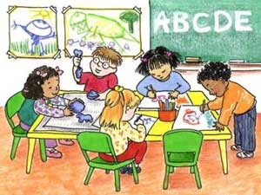

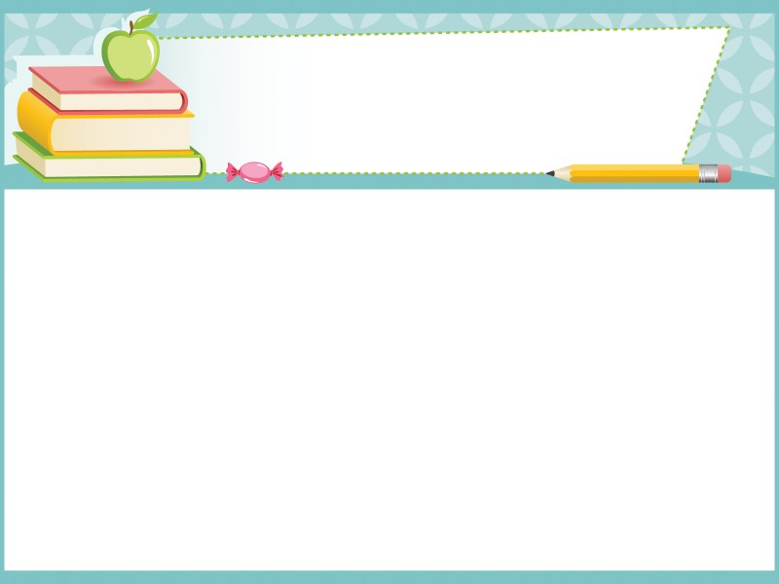

Yearly Themes

All year January
All about me Happy New Year
Jesus, prayer Winter
Colors Snow Penguins
Shapes
Numbers February
Counting Groundhog Day
Weather Valentine’s Day
President’s Day
October
Fire prevention March
Pumpkins Dr. Seuss
Halloween St. Patrick’s Day
Lent
November
Pilgrims April
Turkeys Spring
Thanksgiving Gardening

December May
Advent Rainbows
Gingerbread Animals
Christmas Mother’s Day
Easter

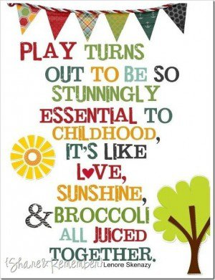
Your child is learning while they are playing.
They learn:

- To get along with others, to be cheerful, polite, and fair.

- To share with others, toys, games, and experiences.

- To explore new things.

- To express himself or herself with words, playdough, paint, crayons, and music.

- To plan what to do next?

- To listen to stories and directions.

- To look at books and learn how to use them.

- To use new words learned from live experiences.

- To spot differences in colors, sizes, shapes, and sounds.

- To care for self and belongings by cooperatively picking up.

- To write by dictating words for the teacher to write.

- To count by relating numbers to specified groups of objects.

- To play inside/outside developing muscles and taking turns.

- To eat with others learning to relax, and practice good manners.

- To care for pets and plants by giving them food and water.

- To think of others on classmates birthdays and making gifts for parents.

- To protect self and to know whom to turn to for protection.

Discipline

All members of the St. Joseph Catholic School community have the right to a healthy and safe environment, respectful treatment by others, freedom from harassment and abuse, and a positive learning environment.

Our discipline policy centers around helping the child maintain self-control and preserve his or her dignity.

We accomplish this by setting realistic and developmentally appropriate expectations. We uphold classroom rules consistently, plan ahead in an effort to avoid problems, encourage children to talk to each other and work problems out, redirect and/or suggest other possibilities when a problem arises. We stay in close contact with parents, communicating strengths and areas for growth. When necessary, reflection time will be used as an opportunity for a child to regain control of their thoughts and feelings.

Our program reserves the right to terminate services to children who present a danger to other children or adults after ALL other avenues have been explored by teacher and parent. Teachers and administrators will make every effort to modify inappropriate behavior, using the techniques mentioned above. Behavior difficulties will be discussed with parents before termination is put into effect, unless the child has caused serious injury to another child or staff member. In that case, parents will be called and termination will be immediate.

FIRE/TORNADO/SHELTER IN PLACE DRILLS

There will be 5 fire drills, 2 tornado drills, and 3 shelter-in-place drills conducted each year. This is in compliance with state and diocesan guidelines. Emergency routes are posted in each classroom.

HEALTH CARE PLAN
Hand washing policies and procedures:
All staff and students routinely use soap and water to wash hands utilizing the rules posted in each hand washing area.

Handling of Bodily Fluids:
Universal precautions are used when handling bodily fluids. Rubber gloves are available in each classroom and biohazard waste containers are located in the office area.

The following steps are used in sanitizing:
Washing the surface with soap and water, rinsing the surface with clean water and sanitizing the surface with the appropriate sanitizing spray mixture.

Illness and Criteria for keeping your child home from school:
If your child has any of the following symptoms or ailments, he or she must remain at home for the health and safety of the rest of the children, and teachers, until symptoms are free for 24 hours:
- Diarrhea or vomiting two or more times in the past 12 hours
- Oral temperature above 100 degrees
- Consistent cough or runny nose
- Conjunctivitis (Pink Eye) or undiagnosed symptoms of conjunctivitis
- Undiagnosed rash
- Chicken Pox, Mumps, or Measles
- Lice: In the event that a child contracts lice, he/she must be NIT free before returning to school. Please expect administration to do a final check upon return.
For communicable diseases, a child must be on prescription medication for 24 hours before returning to preschool.

Parents are asked to notify the school 734-676-2565 if a child will not be attending preschool for any reason. If a child is not attending due to illness, please be specific on diagnosis as we need to report it to Wayne County Disease Control Division. If an illness is one that can be spread throughout the class, parents will receive a note if the illness has been reported to the office.

* Health resources: Several local health resources are available in the area including Red Cross, & Wayne County Health Department.
ILLNESS OR ACCIDENT DURING THE SCHOOL DAY

If your child becomes ill at school, you will be notified and will be expected to pick him/her up as soon as possible.
Whenever possible, for short-term prescription drugs such as antibiotics, we ask that your doctor dose the medication so your child can take it before or after the school day.
If your child needs to take medication during school time, either a prescription or over the counter medication, including cough drops, there is a form in the office that needs to be filled out by your physician.

Reporting Obligations
School staff and Administration are obligated by law to report the reasonable suspicion of physical abuse and/or neglect.

The school cannot contact parents in advance of making a report to the Family Independence Agency. This is followed up by a written report within 72 hours of the complaint.

Exiting your child from the program:
Parents must give a two week advance written notice of removing their child from the program. The two weeks must be paid in full.

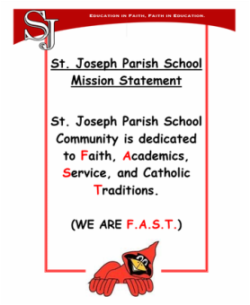

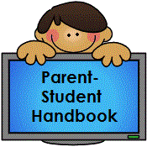

Dear Parents,
Please read the St. Joseph Preschool Handbook with your child(ren) so that everyone is aware of our school’s policies and procedures for the entire year. Please sign and return by the first day of school.
To view online: www.stjosephschooltrenton.com

I have read the handbook with my child(ren), and we agree to abide by all the policies and procedures listed in the Handbook:

Parent’s Name (Please print):______________________________________

Parent’s Signature:______________________________________________

Child(ren) name and grade (3 for 3 year program / 4 for 4 year program)

_______________________________ ______________________________

_______________________________ ______________________________

