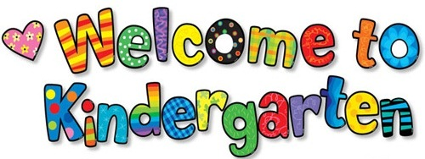
SUPPLY LIST 2017-2018

Child Supplies: To be labeled with the child’s name
- Book Bag
- Lunch Box
- Yellow Folders
- Markers
- Paint Shirt

The following items will be stored and shared in the classroom:

1 | Elmer’s white school glue
4 | 24 count Crayola crayons
1 | 4 pack Playdough (red, white, blue, yellow)
2 | Rolls of paper towels
2 | Boxes of moistened towelettes (baby wipes)
12 | Glue sticks
1 | Box Crayola washable markers-Classic Colors
4 | Yellow pocket folders with child’s first & last name printed at the top right hand corner
2 | Boxes of Kleenex (large size)
1 | Paint smock or oversized shirt (labeled with name)
1 | Clorox wipes
1 | Box of Quart Size Ziploc Bags

Girls Only | Boys Only
1 pack paper cups | Paper plates
Sponges | Lunch bags
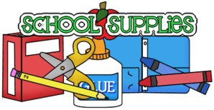

Please put all of the classroom items in a large paper bag.
Label the bag with your child’s name and bring the bag with you to the
Kindergarten Orientation.

